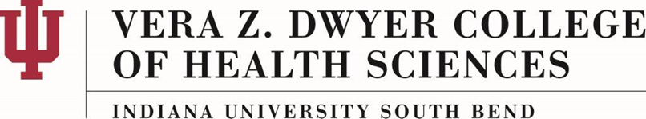

Volunteering as a Rep. of IUSB Vera Z. Dwyer College of Health Sciences
AS-20-A

About This Policy:

Effective Date:
02-24-2017

Date of Last Review/Update:
02-24-2017

Responsible College Administrator/Committee:
Dwyer College of Health Sciences Faculty (DCHSF) President

Scope:

This policy is for the IUSB Vera Z. Dwyer College of Health Sciences.

Policy Statement:
The purpose of this policy is to explain the IUSB-Dwyer College of Health Sciences (IUSB-CHS) guidelines for acting as a representative of the College.

Policy:
The College of Health Sciences students are often asked to help at health fairs and other health related activities. Students should not volunteer as a CHS student unless the activity is a part of approved volunteer work for the college, an approved experience for a course, or an event endorsed by the IUSB- CHS. Activities sponsored through a student organization or club, which are approved by the faculty representative are exempt. Otherwise, please check with faculty if you are asked to participate before committing to help.

History:

