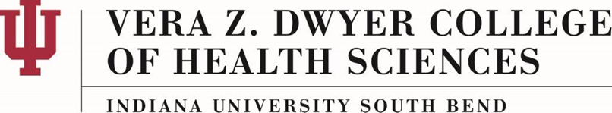

Licensed Students Policy
AS-18-B

About This Policy:

Effective Date:
02-24-2017

Date of Last Review/Update:
02-24-2017, 02-12-2021

Responsible College Administrator/Committee:
Dwyer College of Health Sciences Faculty (DCHSF) President

Scope:

This policy is for the IUSB Vera Z. Dwyer College of Health Sciences.

Policy Statement:
The purpose of this policy is to identify the reporting process(es) for students who hold a healthcare-related license or certification registered with a state public licensing agency (ipla.gov).

Policy:
Students who hold a healthcare-related license or certification registered with a state public licensing agency (e.g.: ipla.gov) are required to provide documentation of this licensure upon admission to the College of Health Sciences.*

The IUSB Vera Z. Dwyer College of Health Sciences (IUSB-CHS) will abide by all obligations outlined by the Professional Licensing Agency of the state, including the duty to report. Should the occasion arise in which the IUSB-CHS has the duty to report a licensed student to the state, an official report will be filed by the Program Director or Academic Assistant Dean.

*This policy applies to Health Science majors at the point of internship or community course specific.

History:

