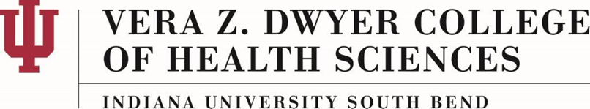

Seven-Year Course Limit

AC-02-A

About This Policy:

Effective Date:
08-01-2019

Date of Last Review/Update:
10-11-2019

Responsible College Administrator/Committee:
Dwyer College of Health Sciences Faculty (DCHSF) President

Scope:

This policy is for the IUSB Vera Z. Dwyer College of Health Sciences.

Policy Statement:
The purpose of this policy is to outline the science course age requirement for the undergraduate students in the IUSB Vera Z. Dwyer College of Health Sciences (IUSB-CHS).

Policy:
This policy applies to the following courses:
- Life span development;
- Required sciences; and
- Statistics.

These courses must have been completed within seven (7) years prior to the semester in which a student begins the program.

Program Directors may allow an exemption to students whose sciences have been completed over 7 years ago. Exemptions include, but are not limited to, work experience, licensures, and certifications.

History:

